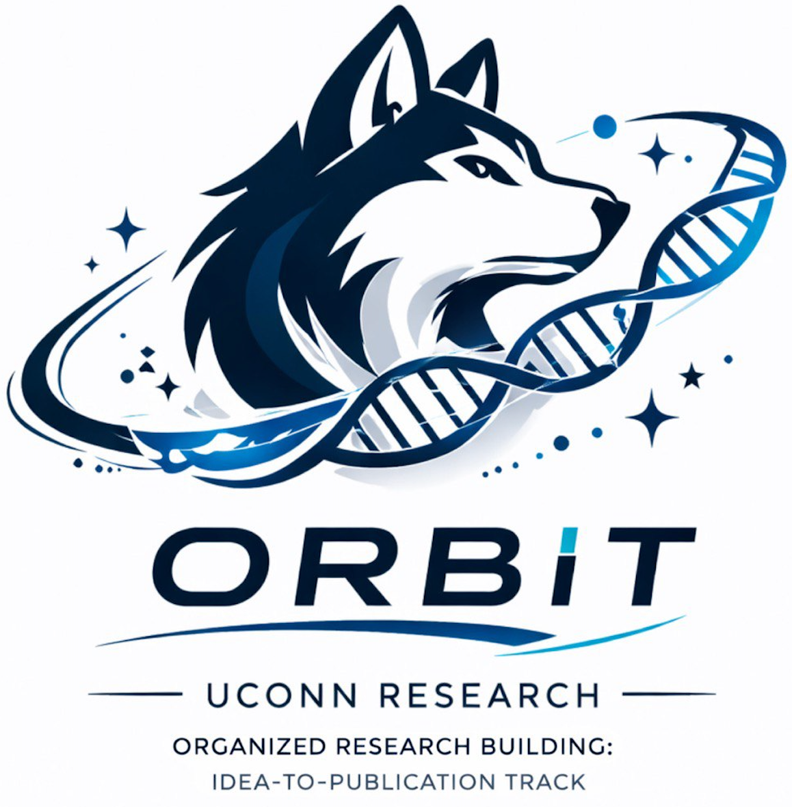 | O.R.B.I.T.  Organized Research Building: Idea-to-Publication Track
OPEN ACCESS RESOURCE

Building a Research Resume
  - A one-page guide for translating coursework, projects, research, leadership, and technical skills into a focused application document.
BEST FOR Students applying to research labs, internships, summer programs, entry-level research roles, or other opportunities that request a resume.
THE BIG IDEA A resume is a targeted argument that your experience matches a role. Every line should earn its space.

1. Keep the structure simple
A research or internship resume can usually be organized into four core sections: Education, Research/Projects, Experience, and Skills. Add Leadership or other sections only when they strengthen the application. Keep the document to one page unless the opportunity explicitly accepts more.
Section | What belongs there
Education | University, degree, major, expected graduation, GPA when strong or required, and selectively tailored coursework.
Research / Projects | Independent projects, lab work, course research, O.R.B.I.T. outputs, datasets, posters, or other scholarly work.
Experience | Jobs, volunteering, leadership, teaching, clinical, design, communication, or operations work that demonstrates relevant ability.
Skills | Research, technical, communication, language, and certifications that are relevant to the role.

2. Write bullets that show evidence
A strong research bullet usually combines an action with the object of the work, the method or tool used, and an output or quality-control step. The goal is to show what you actually did rather than list responsibilities in vague terms.
Bullet pattern | Example
Action + object + method + output | Synthesized 38 peer-reviewed articles using a structured extraction matrix to identify three gaps in undergraduate research training.
Tool + task + quality control | Cleaned survey responses in Excel and documented exclusion decisions to preserve a reproducible analysis trail.
Audience + deliverable + result | Designed a poster-ready visual abstract translating findings for a non-specialist undergraduate audience.
Leadership + system + continuity | Created a shared research-hours tracker to standardize member documentation across projects and semesters.

3. Name skills the way research teams use them
“Microsoft Office” or a random list of software often says less than a focused description of what you can do. Group skills by research function and only claim abilities you can actually demonstrate.
Skill area | Examples
Literature | Boolean search strategy, evidence synthesis, citation management, matrix coding.
Data | Data cleaning, codebook development, descriptive statistics, visualization, reproducible logs.
Writing | Abstract drafting, manuscript revision, poster text, cover letters, PI outreach.
Operations | Timeline tracking, meeting minutes, documentation systems, workshop coordination.

4. Tailor the resume to the role
Use standard headings so both humans and applicant-tracking systems can understand the document. Mirror keywords from the role only when they truthfully describe your experience. Avoid generic objective statements unless you need to explain a major career pivot. When a portal is strict, a plain-text-friendly layout is safer than a design built from complex tables or graphics.

5. Resume or CV?
Use a resume when the application expects a focused, usually one-page summary tailored to a specific role. Use an academic CV when the goal is to document a broader scholarly record, including research interests, multiple projects, presentations, publications or manuscripts, teaching, awards, and academic skills. If the instructions tell you which document to submit, follow them.
WHAT GOOD LOOKS LIKE A reviewer can scan the page and immediately see the education, research or project experience, transferable experience, and skills that matter for the opportunity — without hunting through unrelated information.

Helpful standards & references
These are starting points, not substitutes for the requirements of a specific journal, conference, institution, or research team.
- UConn Career Center resume/CV/cover letter guide: https://career.uconn.edu/resources/resume-cv-cover-letter-guide/
OPEN ACCESS This O.R.B.I.T. resource is designed for educational use and may be shared with students. Always follow the requirements of your institution, research supervisor, journal, conference, or program when those requirements differ.

