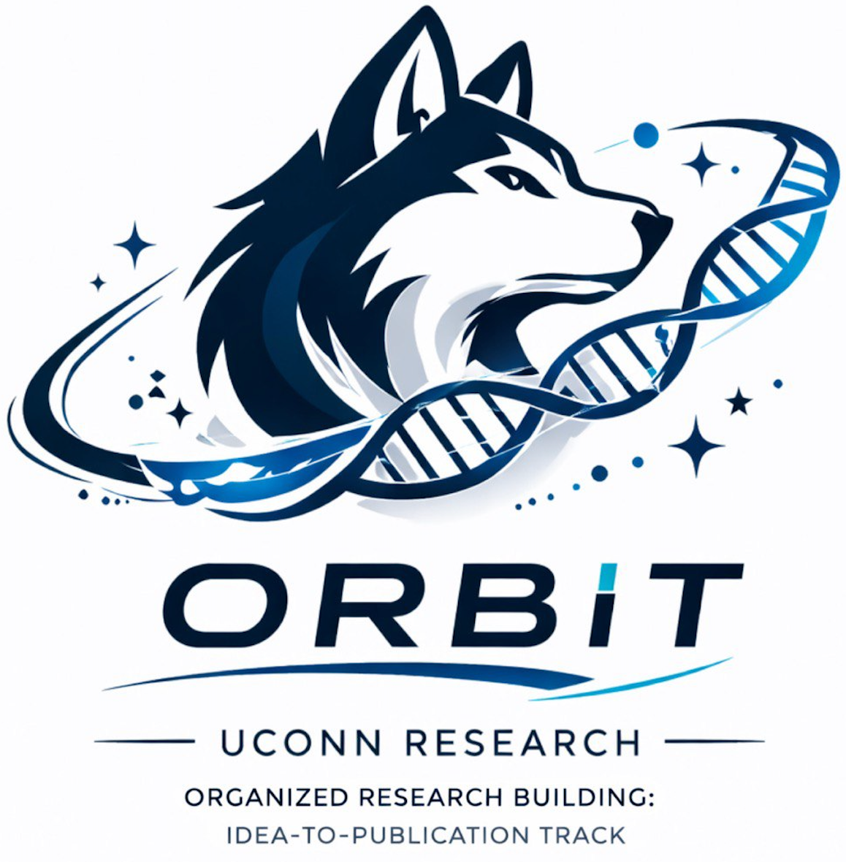 | O.R.B.I.T.  Organized Research Building: Idea-to-Publication Track
OPEN ACCESS RESOURCE

How to Prepare a Research Submission
  - A student-friendly guide to choosing an outlet, checking credibility, preparing metadata, and submitting scholarly work responsibly.
BEST FOR Students preparing a manuscript, abstract, or other scholarly product for journal or conference submission.
THE BIG IDEA Submission is not just uploading a Word file. The manuscript, outlet fit, authorship, ethics, files, and metadata all need to be ready for the specific destination.

1. Choose an outlet because the work fits
Start with scope, article type, audience, method expectations, and reputation. Read the aims and scope page and look at recent article titles. If you cannot identify several recent pieces that resemble your topic or approach, the fit may be weak. Confirm that the outlet actually publishes your article type rather than forcing a review, theory paper, or other format into the wrong category.
Question | What to inspect | Decision
Does the topic fit? | Aims/scope page and recent article titles | If you cannot name several similar recent articles, reconsider the outlet.
Does the article type fit? | Author guidelines and published formats | Use the category the work actually belongs to.
Is the audience right? | Who reads the outlet and why | Choose readers who can use or engage with the work.
Can the method be reported properly? | Reporting guideline, word, table, and figure limits | If the methods cannot fit responsibly, use supplementary material or another outlet.
Is the outlet credible? | Publisher, editorial board, indexing, ethics policies | Avoid opaque fees, fake metrics, suspiciously broad scope, or implausibly fast acceptance.

2. Screen for low-credibility journals
A credible journal should have a coherent scope, field-relevant editorial board, transparent fees, realistic peer-review expectations, clear author guidance, ethics information, archiving information, and genuine contact details. Be cautious when a journal covers unrelated fields, imitates the name of a legitimate journal, promises nearly instant acceptance, or hides fees until late in the process.

3. Match the project to the right reporting framework
Many project types have established reporting guidelines. These guidelines help authors make sure readers can understand what was done and how the work should be evaluated. The specific journal may add its own requirements.
Project type | Common guideline or standard
Randomized trial | CONSORT
Observational quantitative study | STROBE
Systematic review / meta-analysis | PRISMA 2020
Qualitative study | SRQR or COREQ, depending on field
Case report | CARE
Protocol | SPIRIT or PRISMA-P
Humanities / theoretical work | Journal instructions and discipline-specific argument/citation standards

4. Resolve authorship, ethics, and transparency before submission
Confirm who qualifies for authorship, the author order, the corresponding author, and final approval of the submitted version. Record contributions such as conceptualization, search, coding, analysis, writing, revision, and supervision. Make sure the manuscript uses accurate wording for IRB approval, exemption, or non-human-subjects status as appropriate. Prepare conflict-of-interest and funding statements, data-availability information, and any required disclosure of AI or other tools, including the task performed, human verification, and responsibility for the final work.

5. Treat the submission portal as part of the publication record
Portal metadata should match the manuscript exactly, including the title, author list, and abstract. Gather ORCID identifiers if required, choose specific keywords, and only suggest reviewers who are appropriate experts without conflicts. Before final approval, read the portal-generated PDF proof. Save the confirmation email and submission date so the team has a clean record of what was sent and when.
WHAT GOOD LOOKS LIKE The outlet clearly fits the work, the journal or conference is credible, the reporting expectations are met, all authors understand the submission, and the files and metadata tell exactly the same story as the manuscript.

Helpful standards & references
These are starting points, not substitutes for the requirements of a specific journal, conference, institution, or research team.
- ICMJE Recommendations: https://www.icmje.org/recommendations/
- EQUATOR Network reporting guidelines: https://www.equator-network.org/reporting-guidelines/
- ICMJE Sending the Manuscript to the Journal: https://www.icmje.org/recommendations/browse/manuscript-preparation/sending-the-submission.html
OPEN ACCESS This O.R.B.I.T. resource is designed for educational use and may be shared with students. Always follow the requirements of your institution, research supervisor, journal, conference, or program when those requirements differ.

