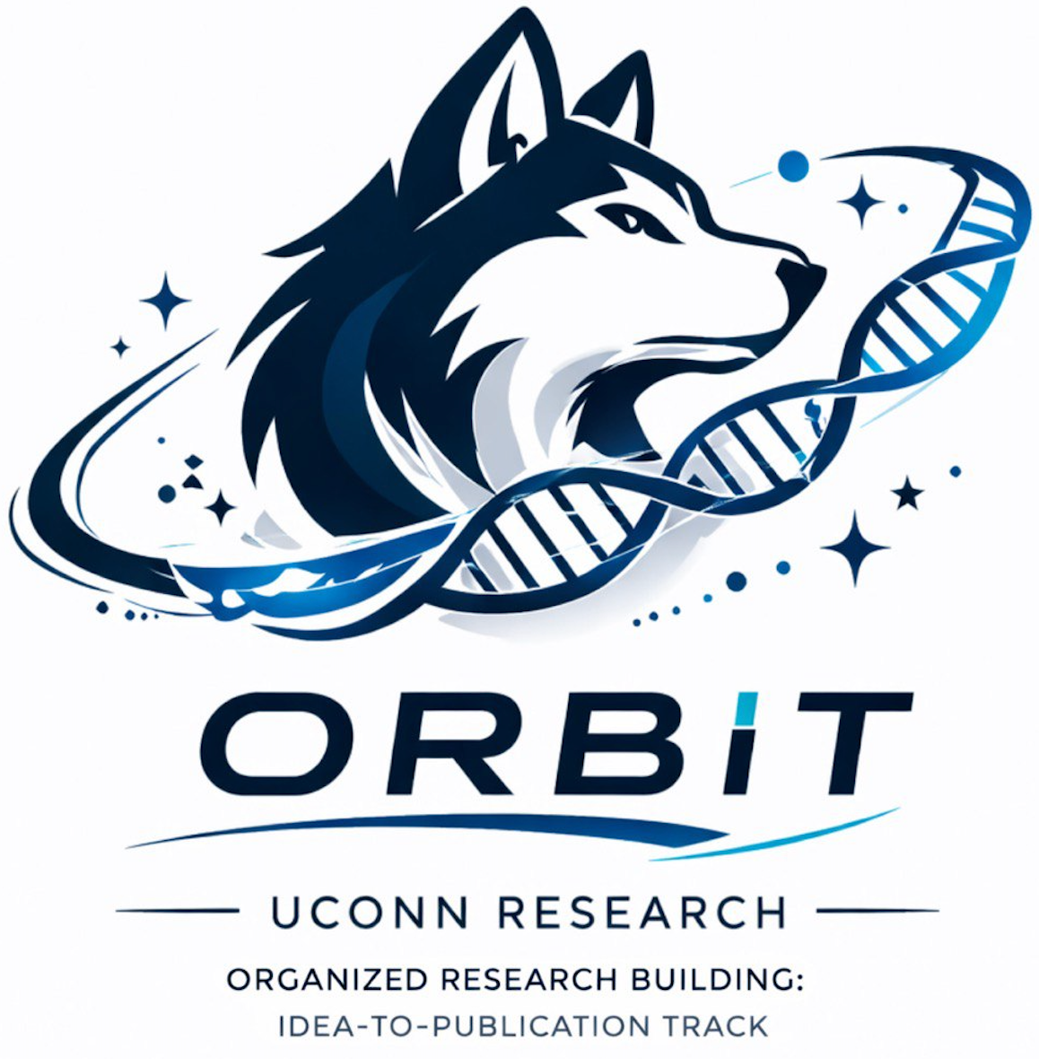 | O.R.B.I.T.  Organized Research Building: Idea-to-Publication Track
OPEN ACCESS RESOURCE

How to Email a PI or Research Mentor
  - A practical outreach guide for contacting faculty, labs, and research mentors without sending a generic cold email.
BEST FOR Students looking for research experience, lab involvement, or a conversation with a potential mentor.
THE BIG IDEA A strong outreach email is short, specific, and evidence-based. In under about 200 words, show that you understand the lab, connect to a real research interest, and are prepared to begin with useful entry-level work.

1. Do enough research to write a real email
Before emailing, identify one specific topic, paper, project, method, population, or finding connected to the lab. The message should make it obvious that you are contacting this researcher for a reason. “I am interested in neuroscience” is too broad; a sentence about neuronal excitability, imaging, social behavior, or a specific computational workflow is much easier for a PI to respond to.

2. Use a subject line that says what the email is about
Situation | Subject line
General inquiry | Undergraduate interested in [specific lab topic] research
After reading a paper | Question about your work on [paper topic] and undergraduate research opportunities
Course connection | Student in [course] interested in [lab method/topic]
No openings posted | Inquiry about future undergraduate research involvement in [Lab Name]

3. Build the email in three short moves
1 | Connection  Introduce yourself and name the specific work that connects to your developing research interest. Include one concrete detail so the message is clearly personalized.

2 | Preparation  Briefly name the skills or outputs you have already started building through a course, O.R.B.I.T., a project, or another experience.

3 | Ask  State that you would be grateful to contribute in an entry-level capacity and ask whether the lab is accepting undergraduate students now or in a future semester. Attach a clean CV or resume.

4. A simple email model
Dear Dr. [Last Name],
My name is [Name], and I am a [year] majoring in [major] at UConn. I am writing because your work on [specific topic/paper/project] aligns with my developing interest in [specific research interest]. I was especially interested in [one concrete detail], because [one-sentence connection].
Through [course/O.R.B.I.T./project], I have begun building skills in [skill 1], [skill 2], and [specific output]. I would be grateful for the opportunity to contribute to your lab in an entry-level capacity and continue developing as a researcher.
I have attached my [CV/resume]. If your lab is accepting undergraduate students now or in a future semester, I would appreciate the chance to speak briefly about whether my interests and preparation align with your team’s needs.
Thank you,
[Name]

5. Follow up once, then move on
If you do not receive a response, a brief follow-up after about 7–10 days is reasonable. Restate your interest, attach the CV again, and ask whether another time or person would be more appropriate. If there is still no response after the second message, stop unless new context appears. A positive response should receive a prompt reply with several meeting windows. If the lab has no openings, thank the researcher and consider asking whether they recommend related labs or coursework.

6. Avoid the most common outreach mistakes
Do not ask a faculty member whether they “do research” when their lab page already answers that question. Do not send the same email with only the name changed. Do not claim expertise in a method you only know by name. Keep attachment names professional, such as LastName_CV_ORBIT_YYYY.pdf. Most importantly, do not make medical school or graduate school requirements the main reason the researcher should take you on.
WHAT GOOD LOOKS LIKE The message is brief enough to read quickly, specific enough to prove genuine interest, honest about your current skill level, and clear about the kind of opportunity you are asking for.

Helpful standards & references
These are starting points, not substitutes for the requirements of a specific journal, conference, institution, or research team.
- UConn Career Center resume/CV/cover letter resources: https://career.uconn.edu/resources/resume-cv-cover-letter-guide/
OPEN ACCESS This O.R.B.I.T. resource is designed for educational use and may be shared with students. Always follow the requirements of your institution, research supervisor, journal, conference, or program when those requirements differ.

